Continuous Integration and Continuous Deployment

Assignment – 2

**Name – ABHISHEK SHARMA**

**Roll No – R171218005**

**Integrating Git, Jenkins, Maven and Nexus**

Start the Jenkins service using the java -jar jenkins.war command in the command prompt

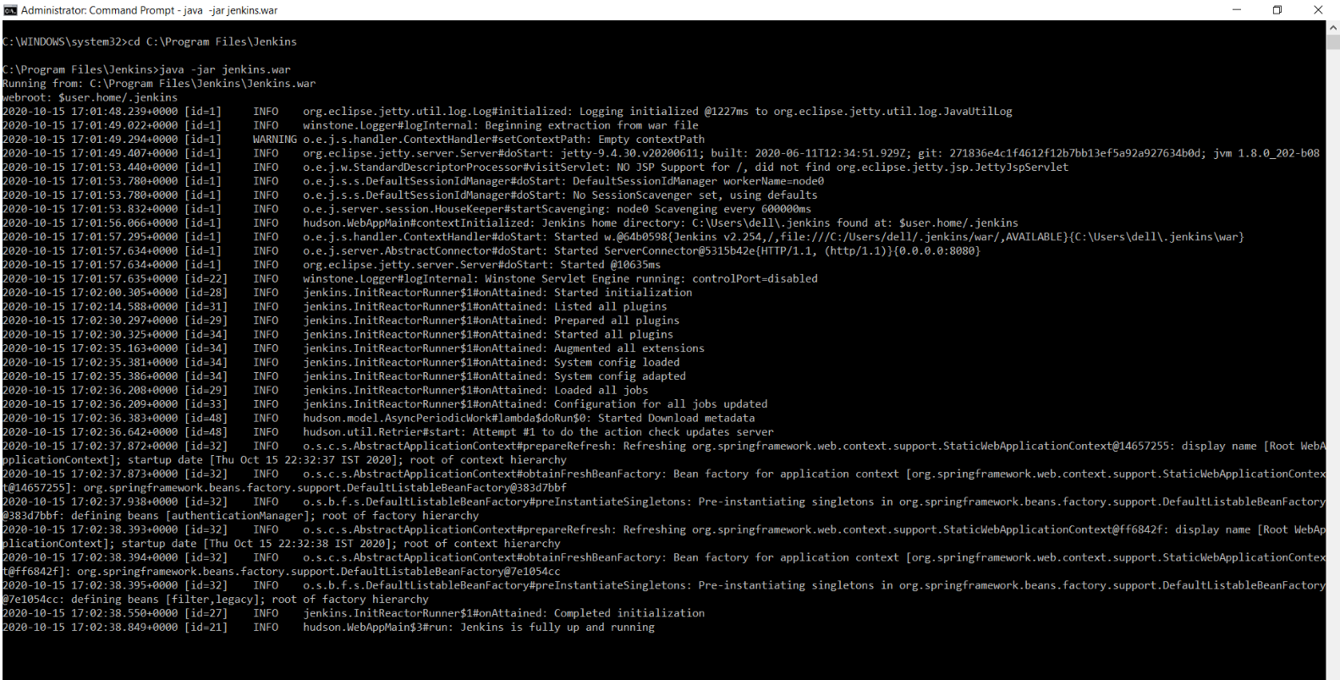

Go to the Jenkins dashboard at localhost:8080

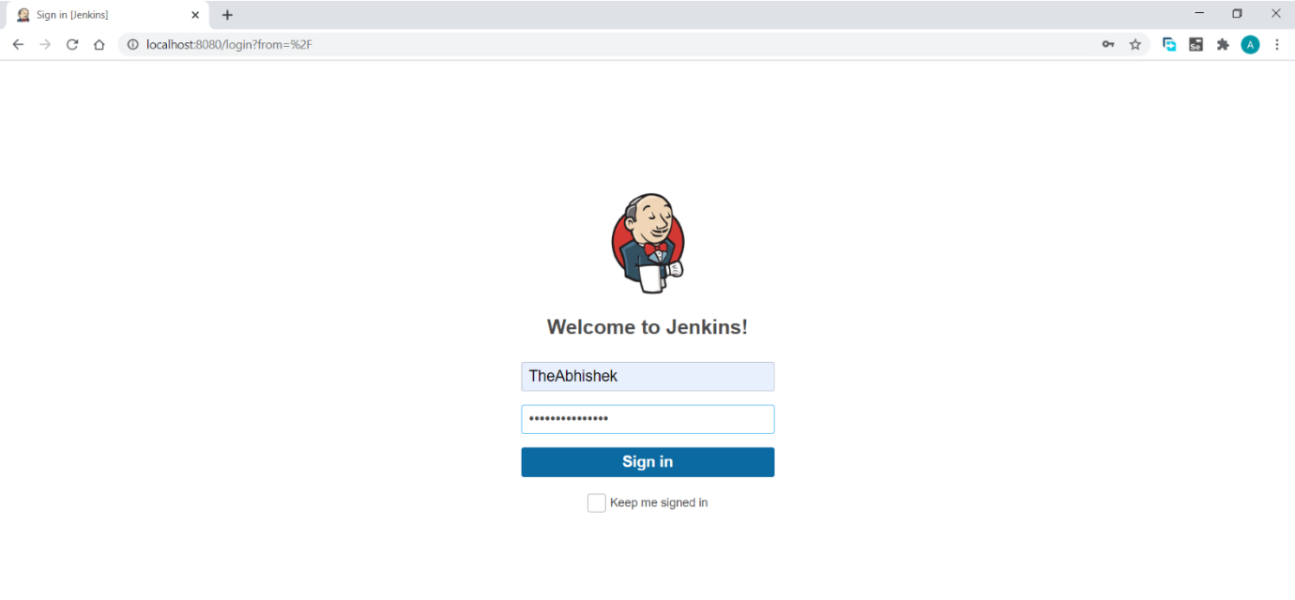

In global tools configuration give path of jdk and maven installation in local machine:

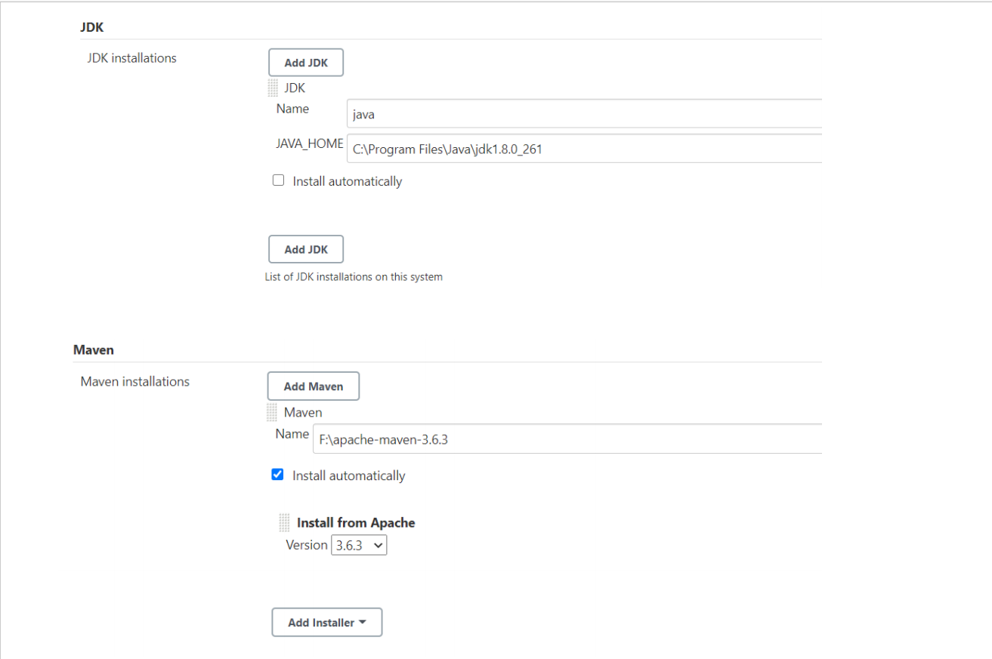

Default port for nexus is 8081:

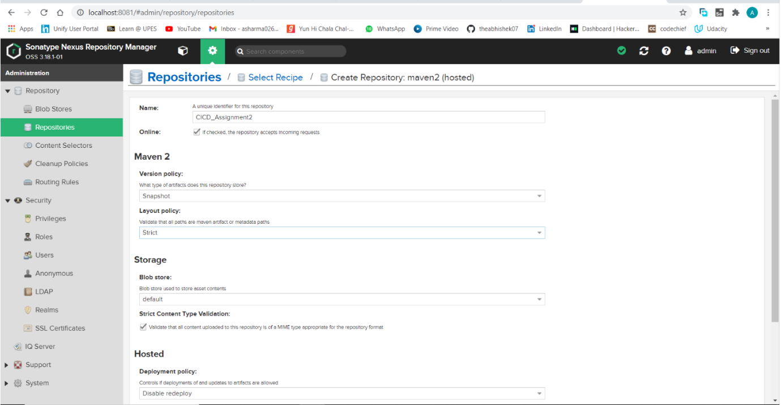

Start nexus, run ‘nexus.exe /run’ command:

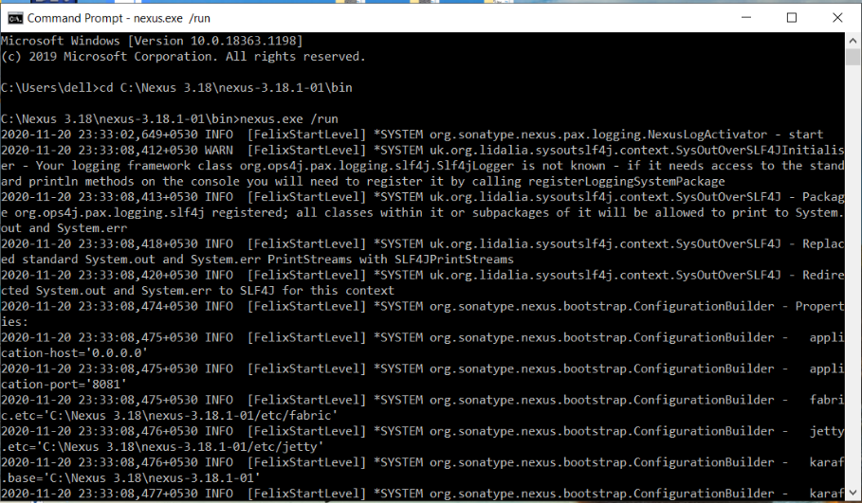

Open nexus on browser (localhost:8081) and create a repository:

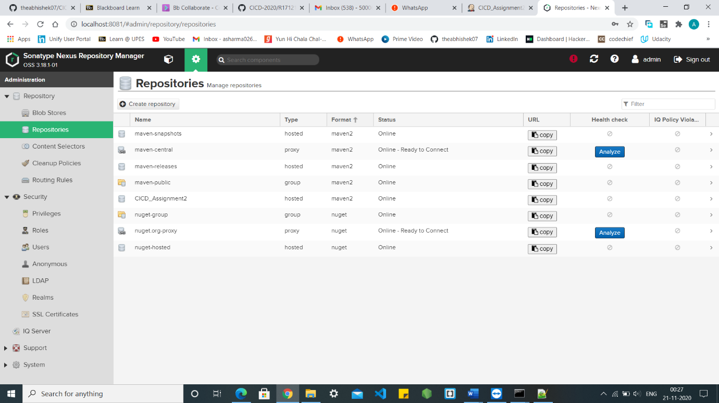

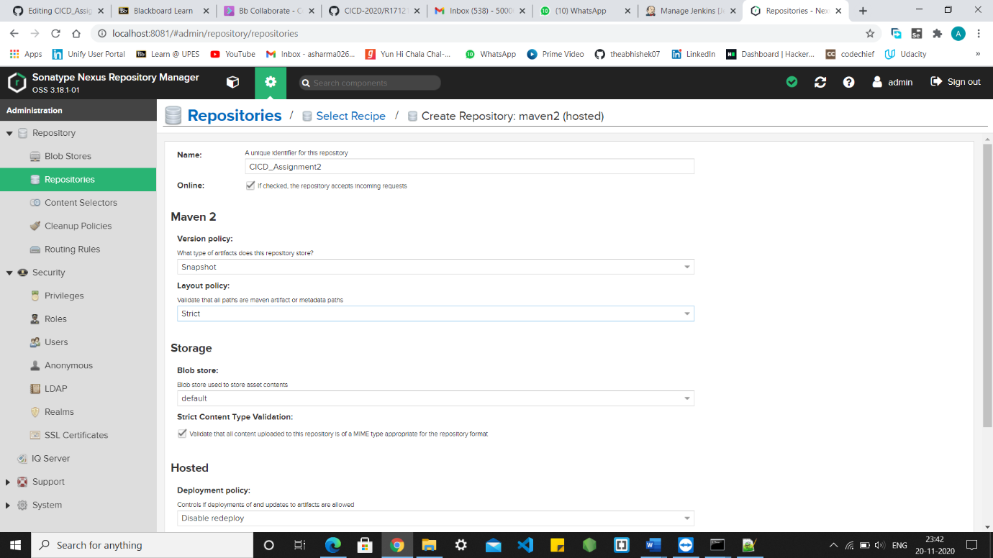

Create maven project:

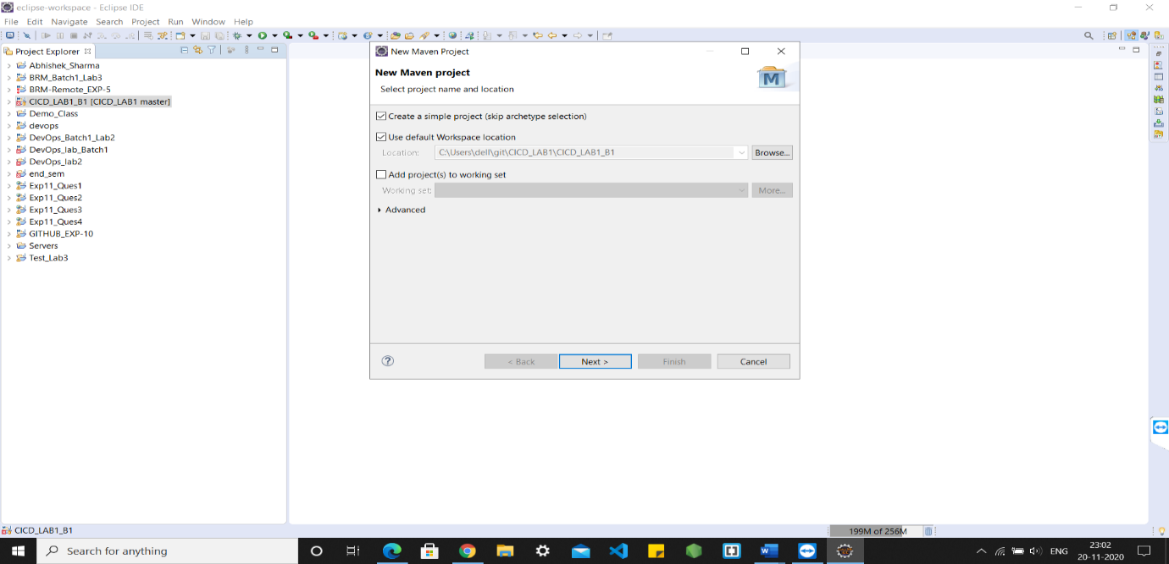

Naming Group id and Artifact id:

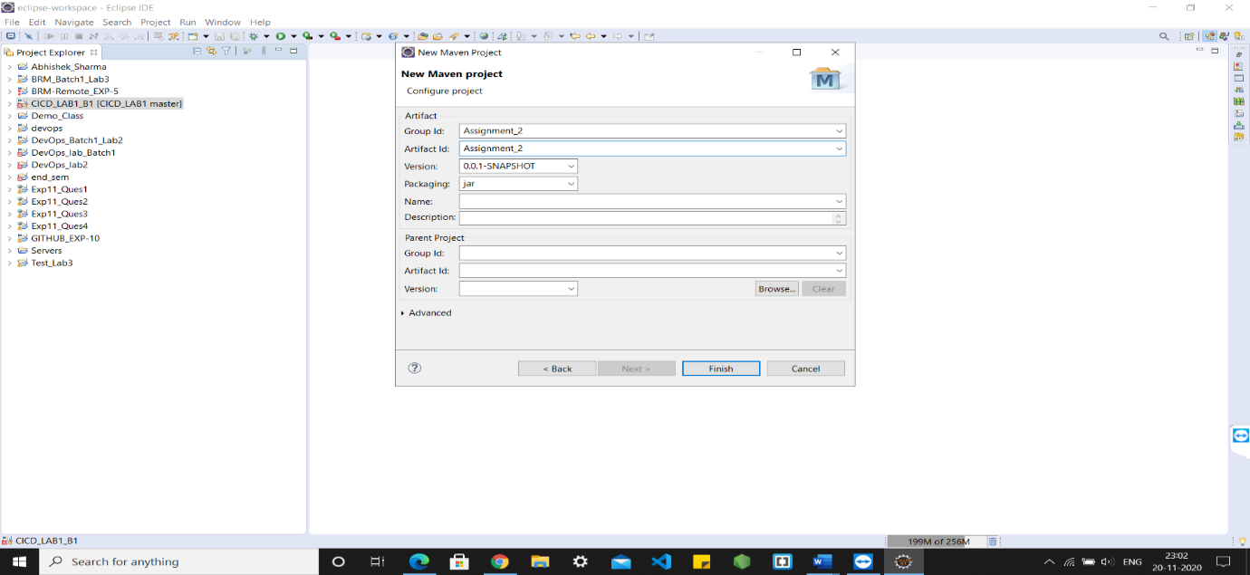

Creating class:

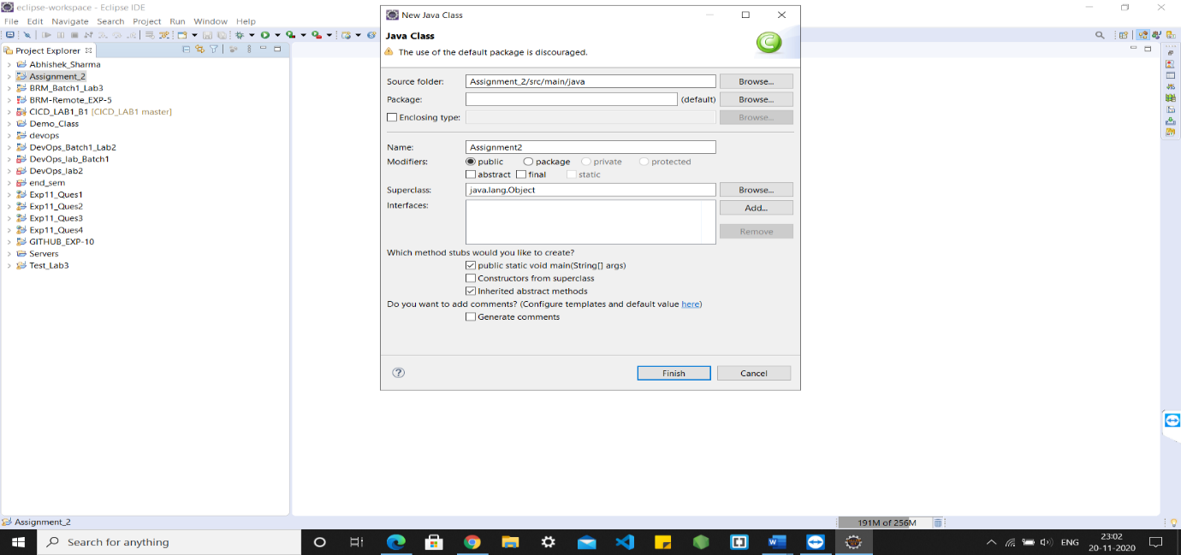

Sample input code:

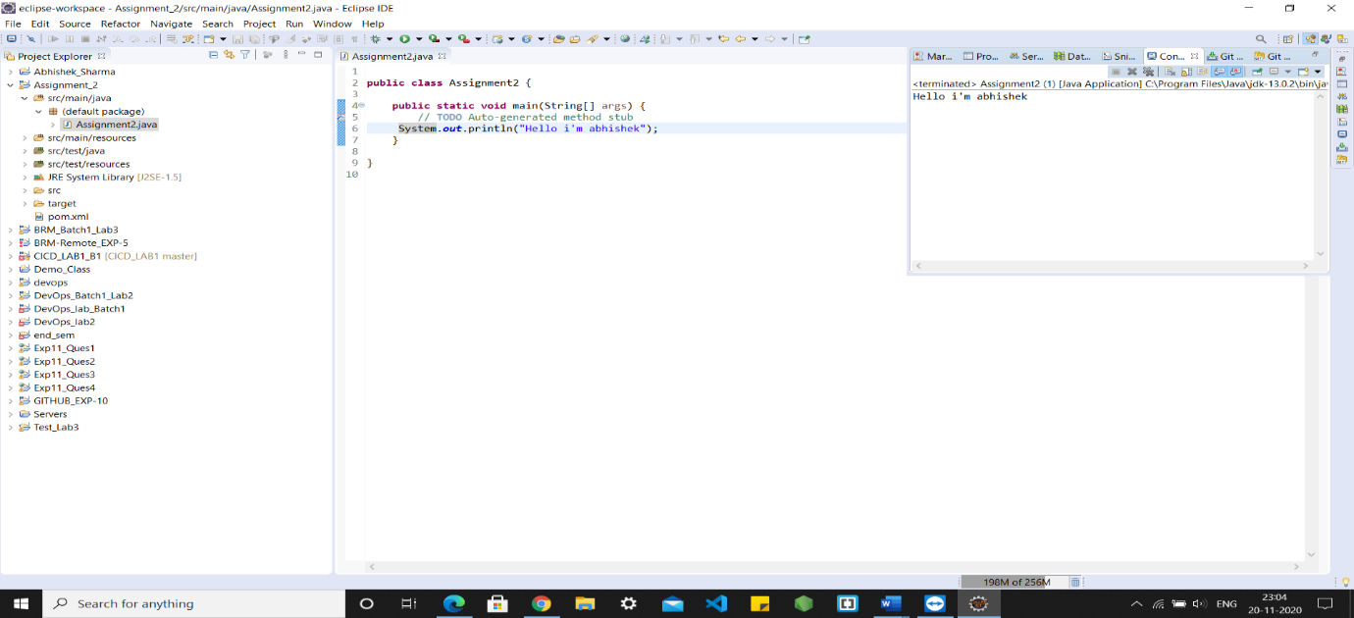

Copying the URL of GitHub repository in maven project:

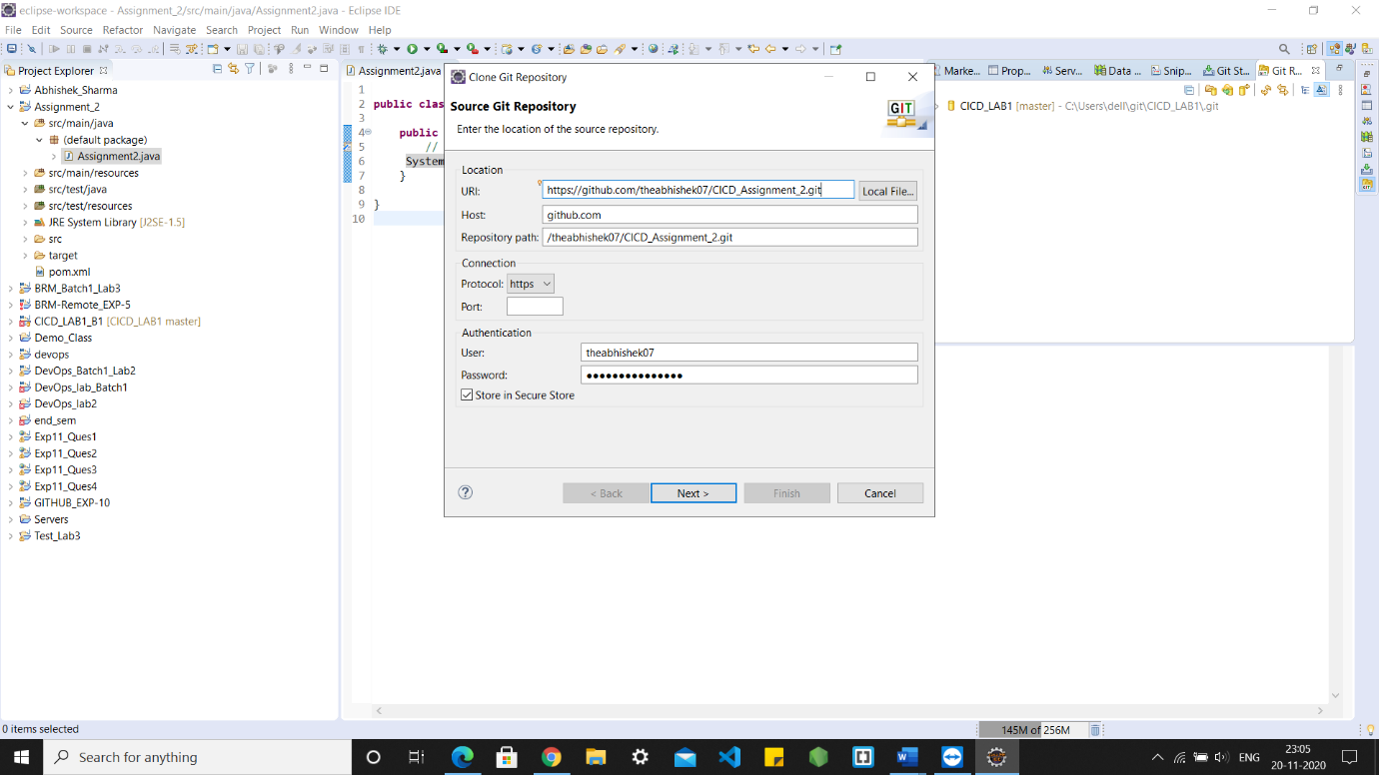

Now the pointer in on master branch on which we are working right now:

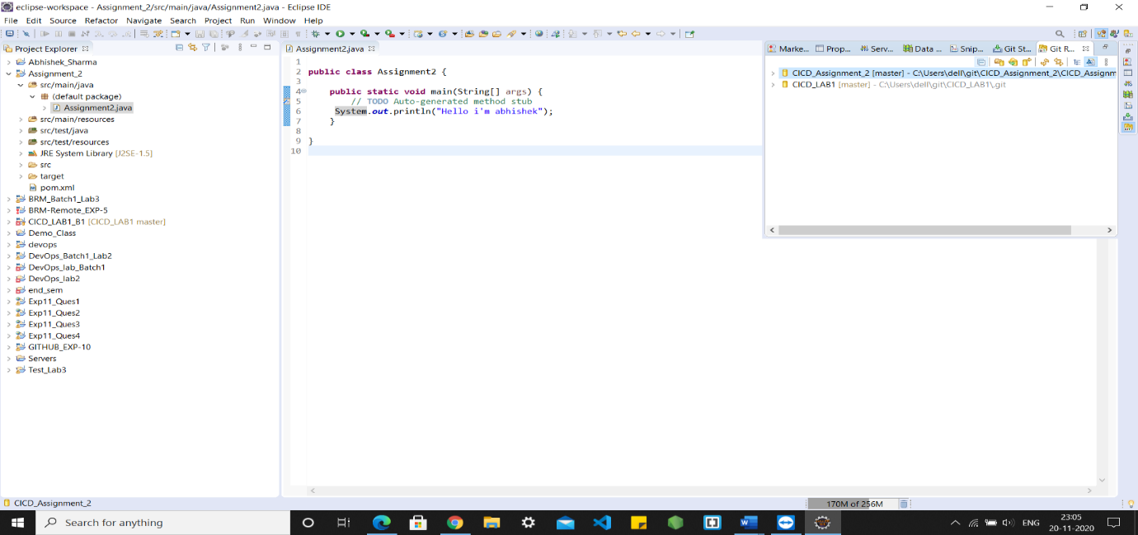

Sharing project on github:

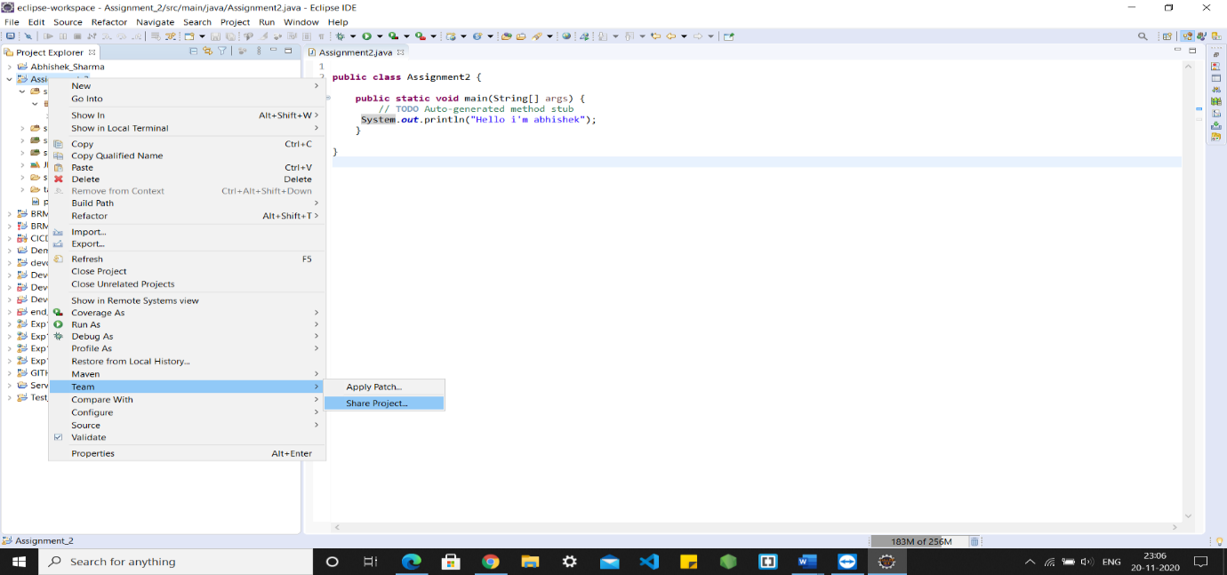

Configuring Git repo:

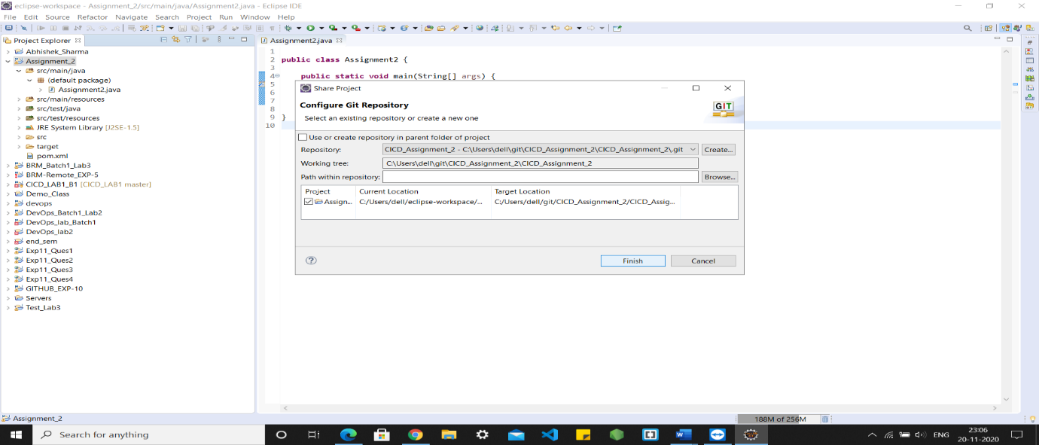

Committing changes:

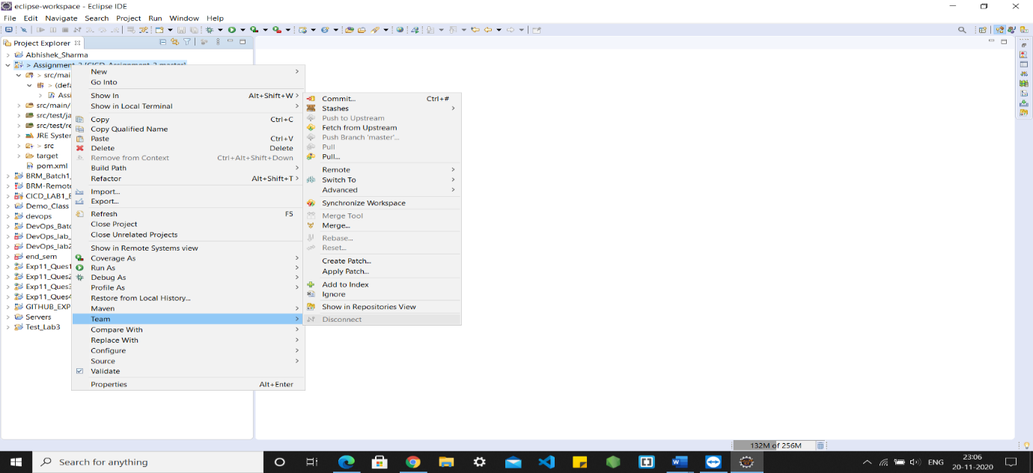

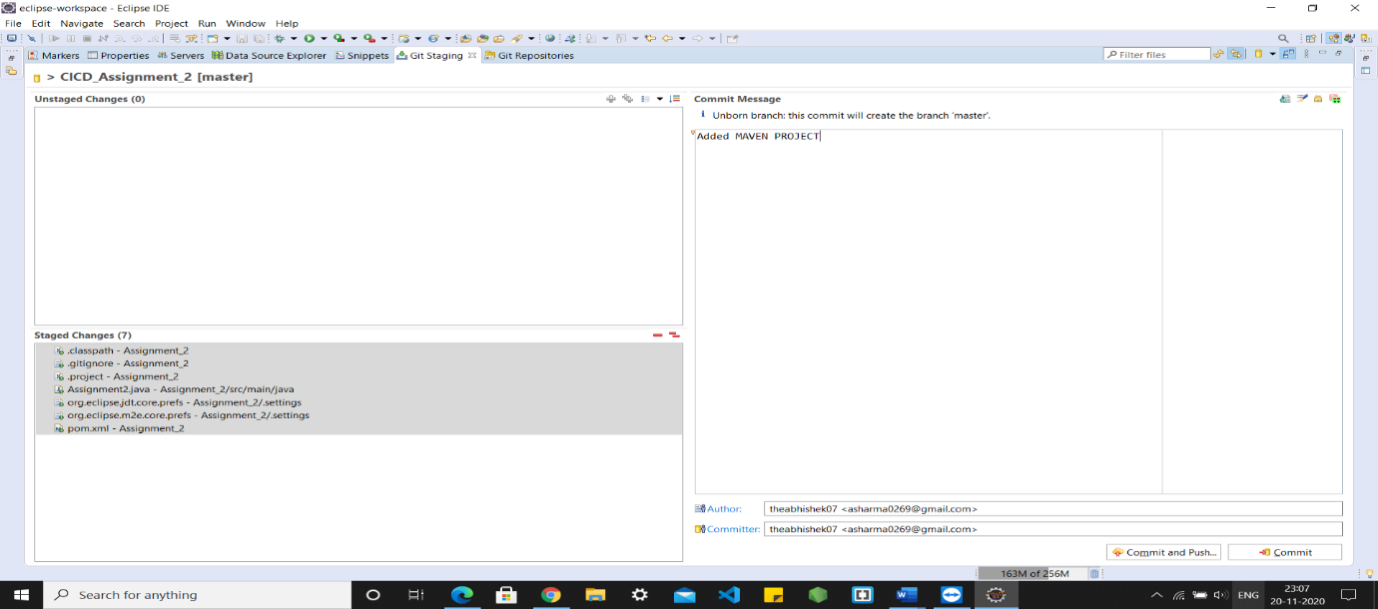

Pushing project on github:

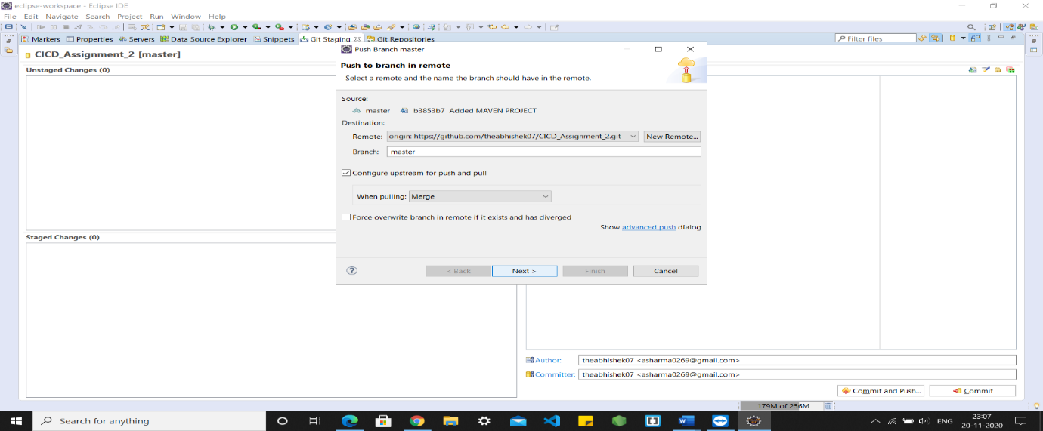

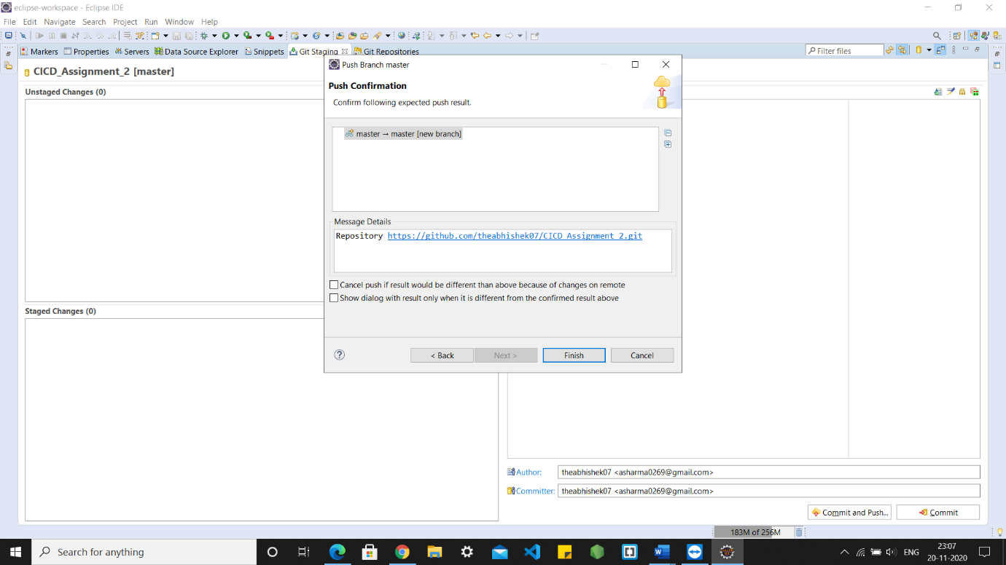

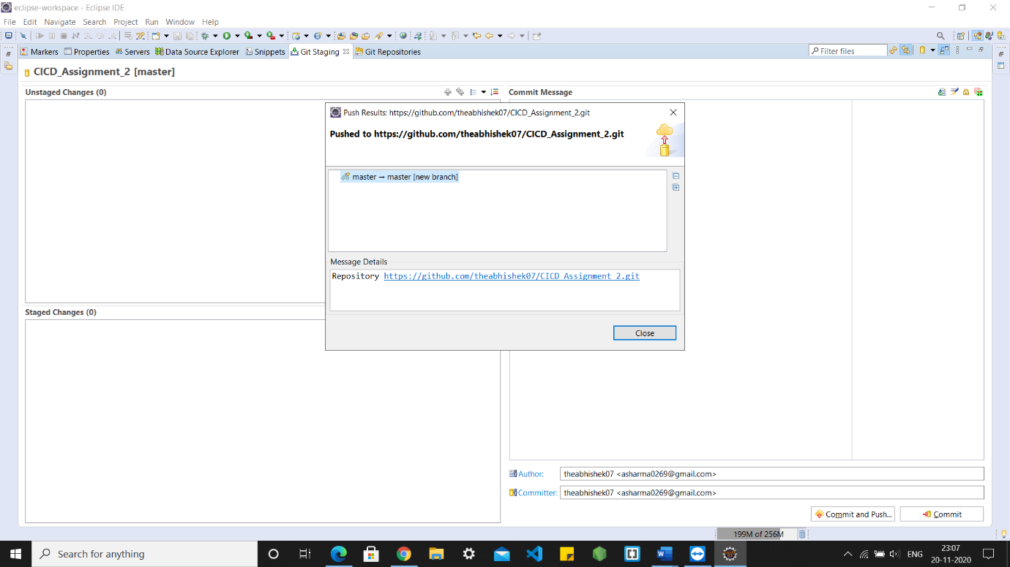

Add server tag in settings.xml file:

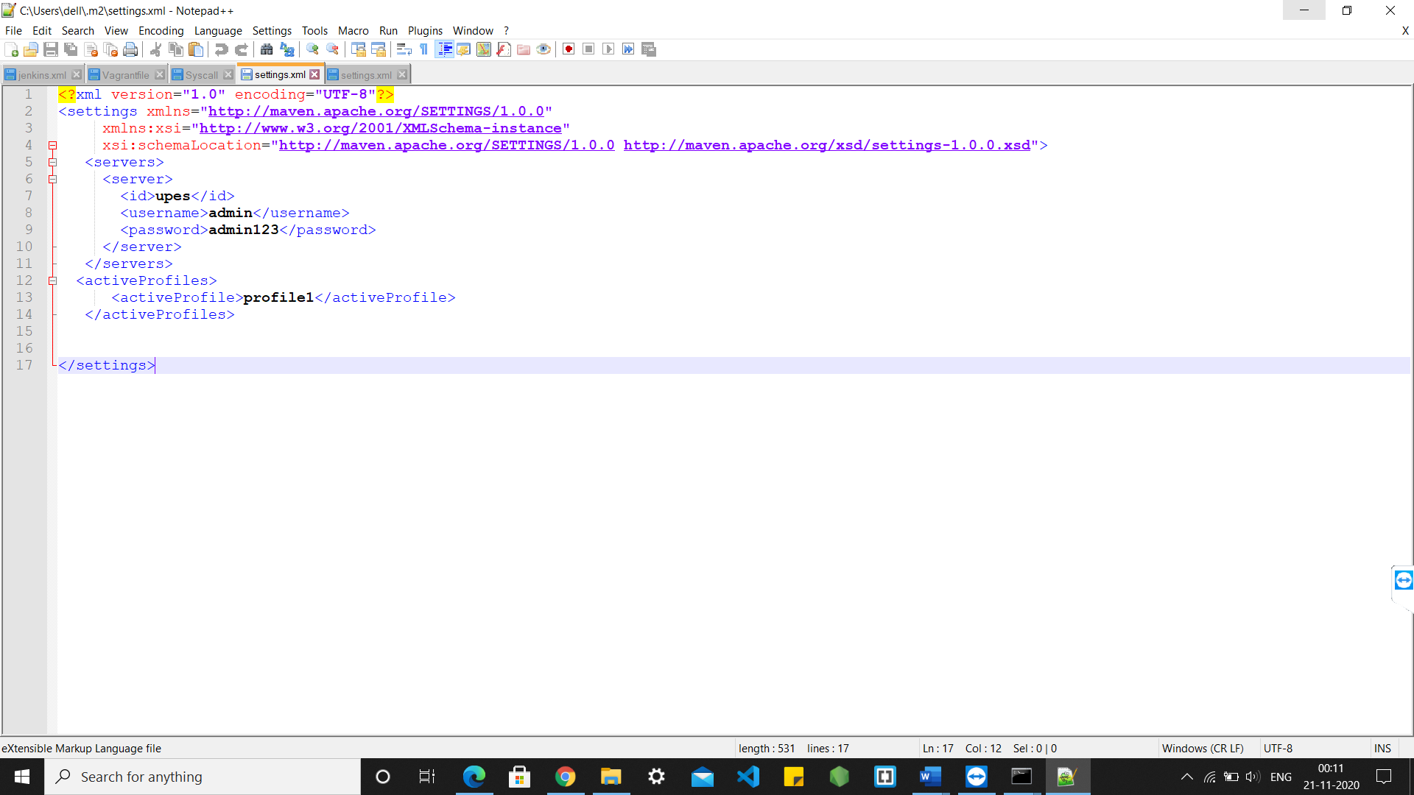

Add distributionManager tag in pom.xml file:

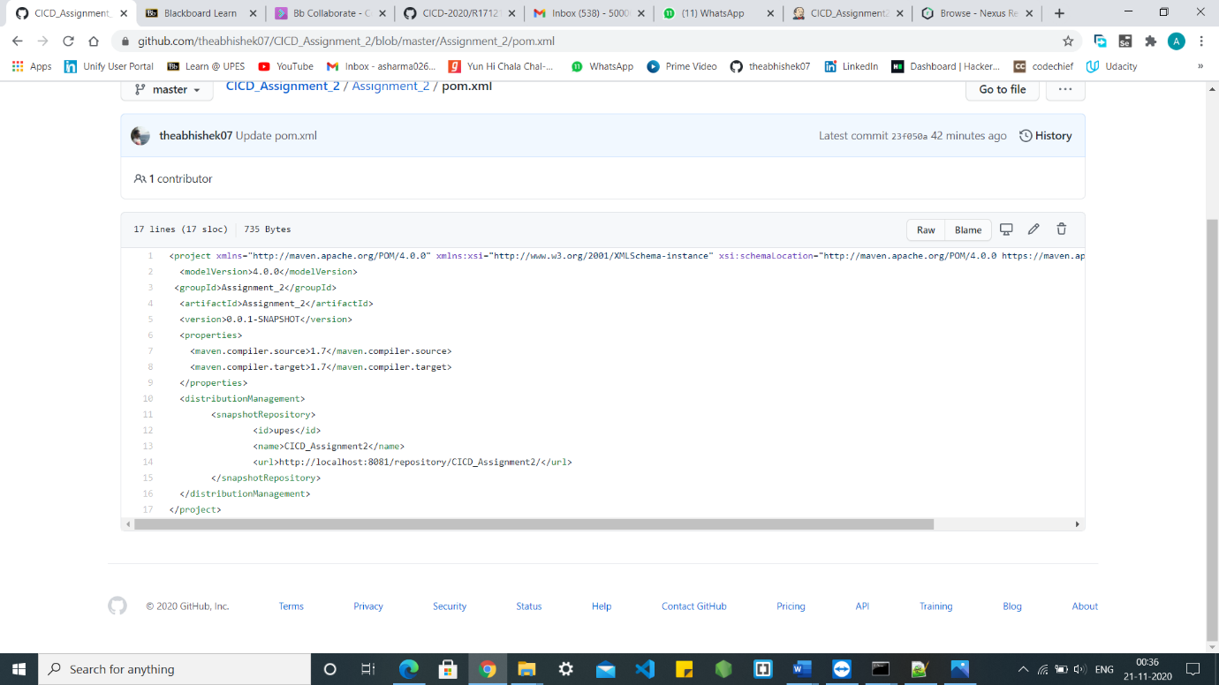

Push the maven project to GithHub:

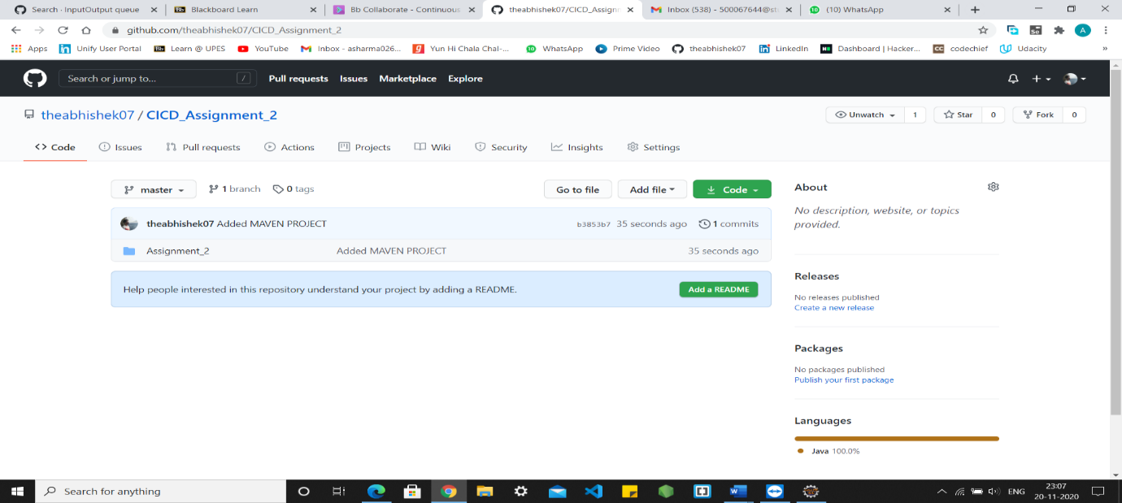

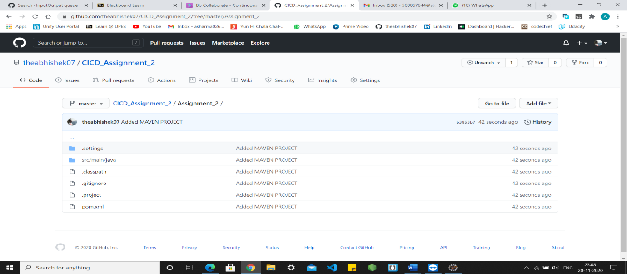

Add Jenkinsfile to the maven project:

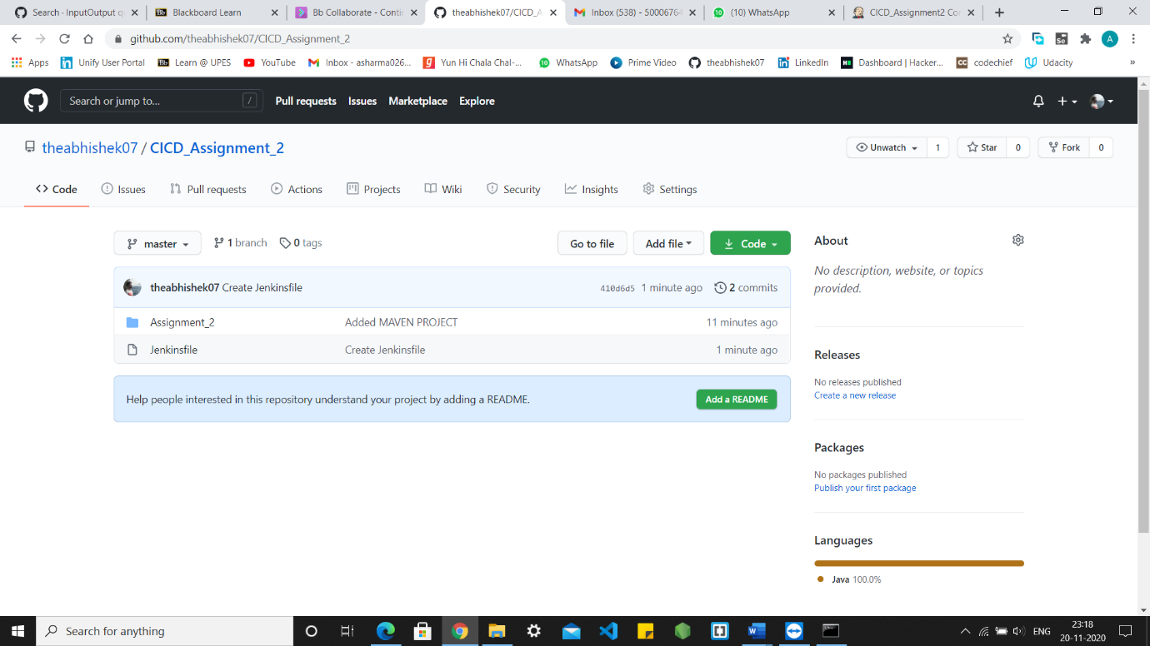

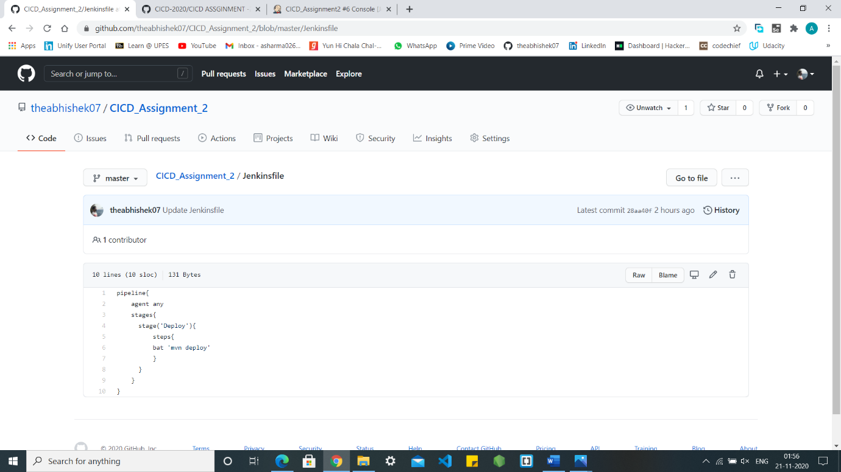

➢ In Jenkins, click on new Item

➢ Select pipeline project and give a name to the project

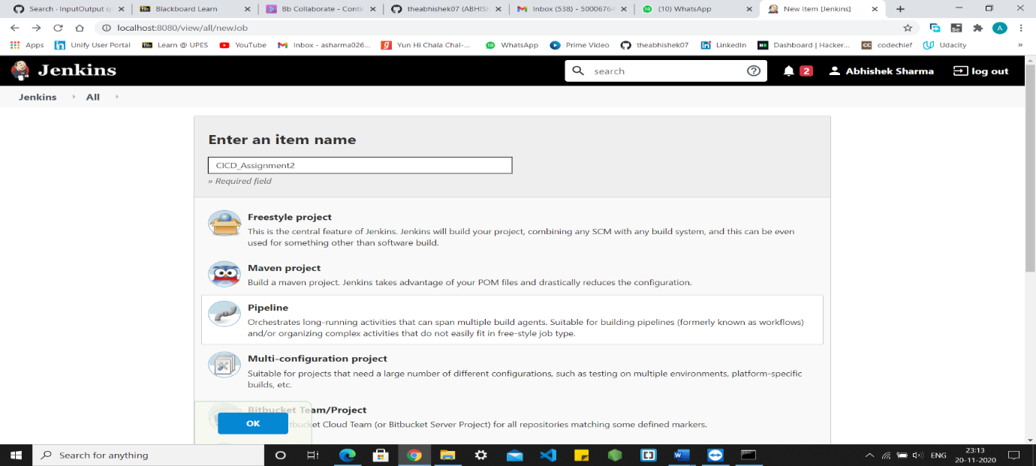

➢ In project pipeline configuration, select SCM, Git and fill the URL of GitHub repository of the maven project

Click on Build Now : 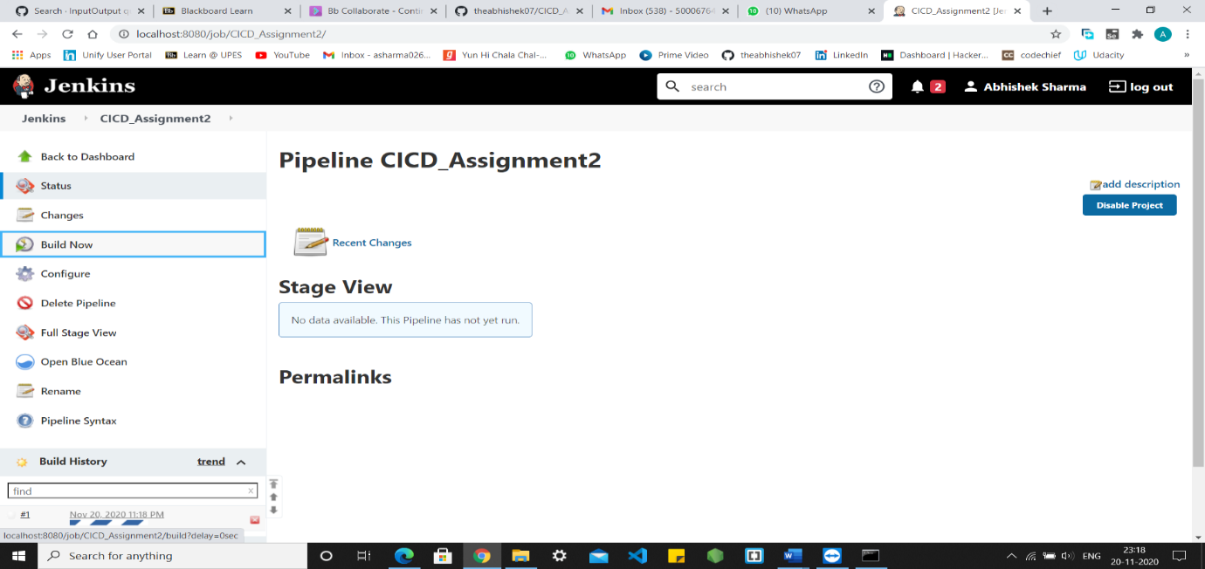

Console Output:

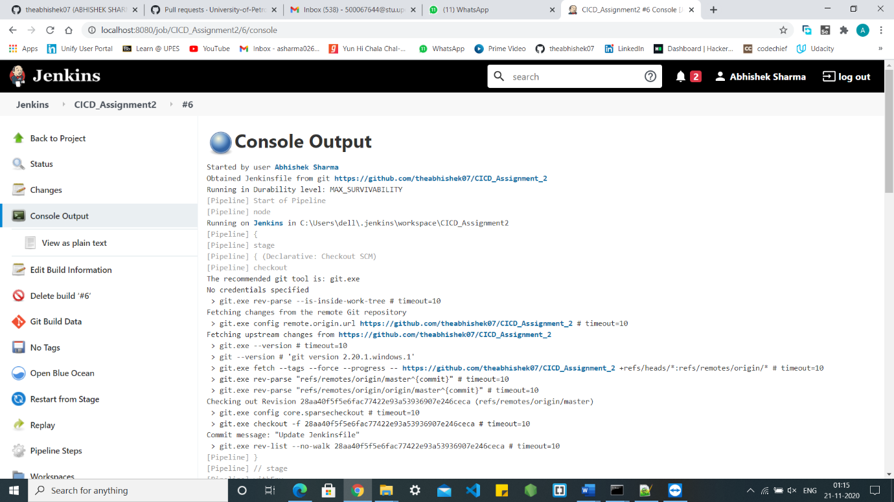

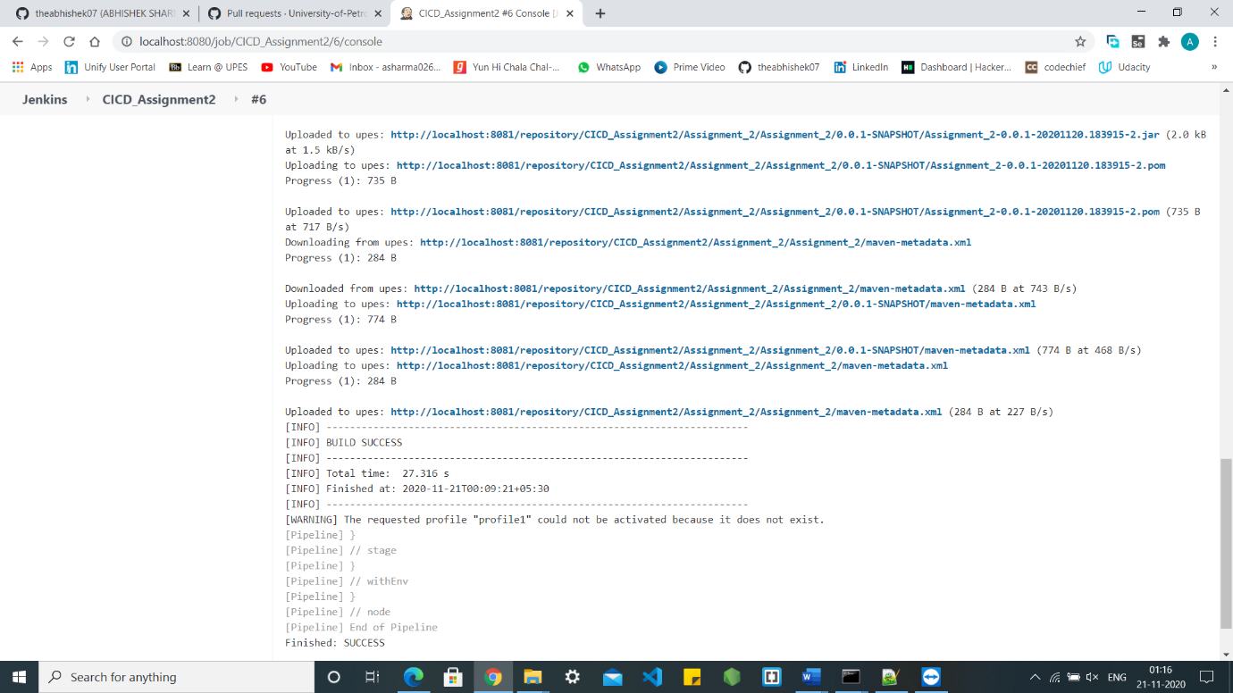

Pipeline created in Jenkins: 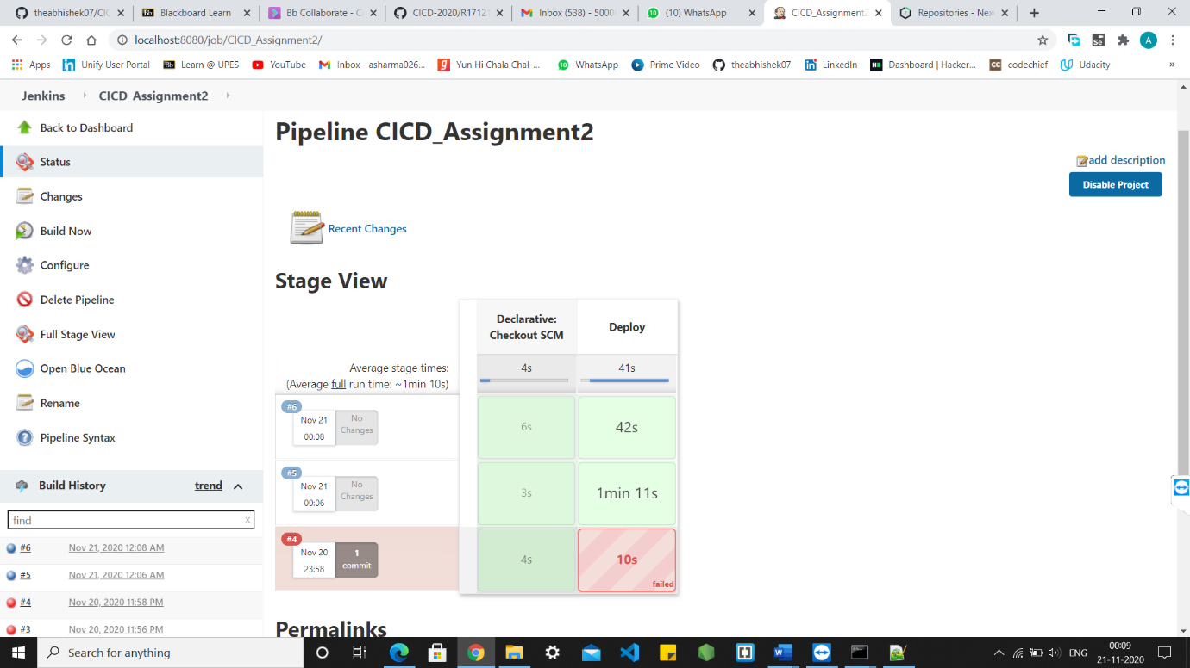

Build generated and pushed to Nexus Server

